**React App Deployment with Docker, CI/CD, and CloudWatch**

**Repo link:** [**vommidapuchinni/my-react-app**](https://github.com/vommidapuchinni/my-react-app)

**Pages live link:** [**https://vommidapuchinni.github.io/my-react-app/**](https://vommidapuchinni.github.io/my-react-app/)

**1. Project Overview**

This project demonstrates a full CI/CD workflow for deploying a React application to staging and production environments on AWS EC2 using Docker. It also includes log monitoring via Amazon CloudWatch.

**Key Features:**

* Separate Staging & Production environments on EC2.
* CI/CD Pipelines implemented using GitHub Actions.
* Docker used for containerized deployments.
* Nginx serves the React application.
* CloudWatch Agent collects logs from containers into AWS CloudWatch Logs.

**2. Prerequisites**

* AWS account with EC2 access.
* IAM role with CloudWatch permissions attached to EC2.
* GitHub repository with your React project.
* GitHub secrets:
  + STAGING_IP → Staging EC2 public IP
  + STAGING_KEY → Staging EC2 private key
  + EC2_IP → Production EC2 public IP
  + EC2_SSH_KEY → Production EC2 private key
  + Access and secrete access keys
* Docker and docker compose installed on EC2.

**3. Create a ReactJS App**

Open git bash and run commands

I recommend Vite (fast dev server)

npm create vite@latest my-react-app -- --template react

cd my-react-app

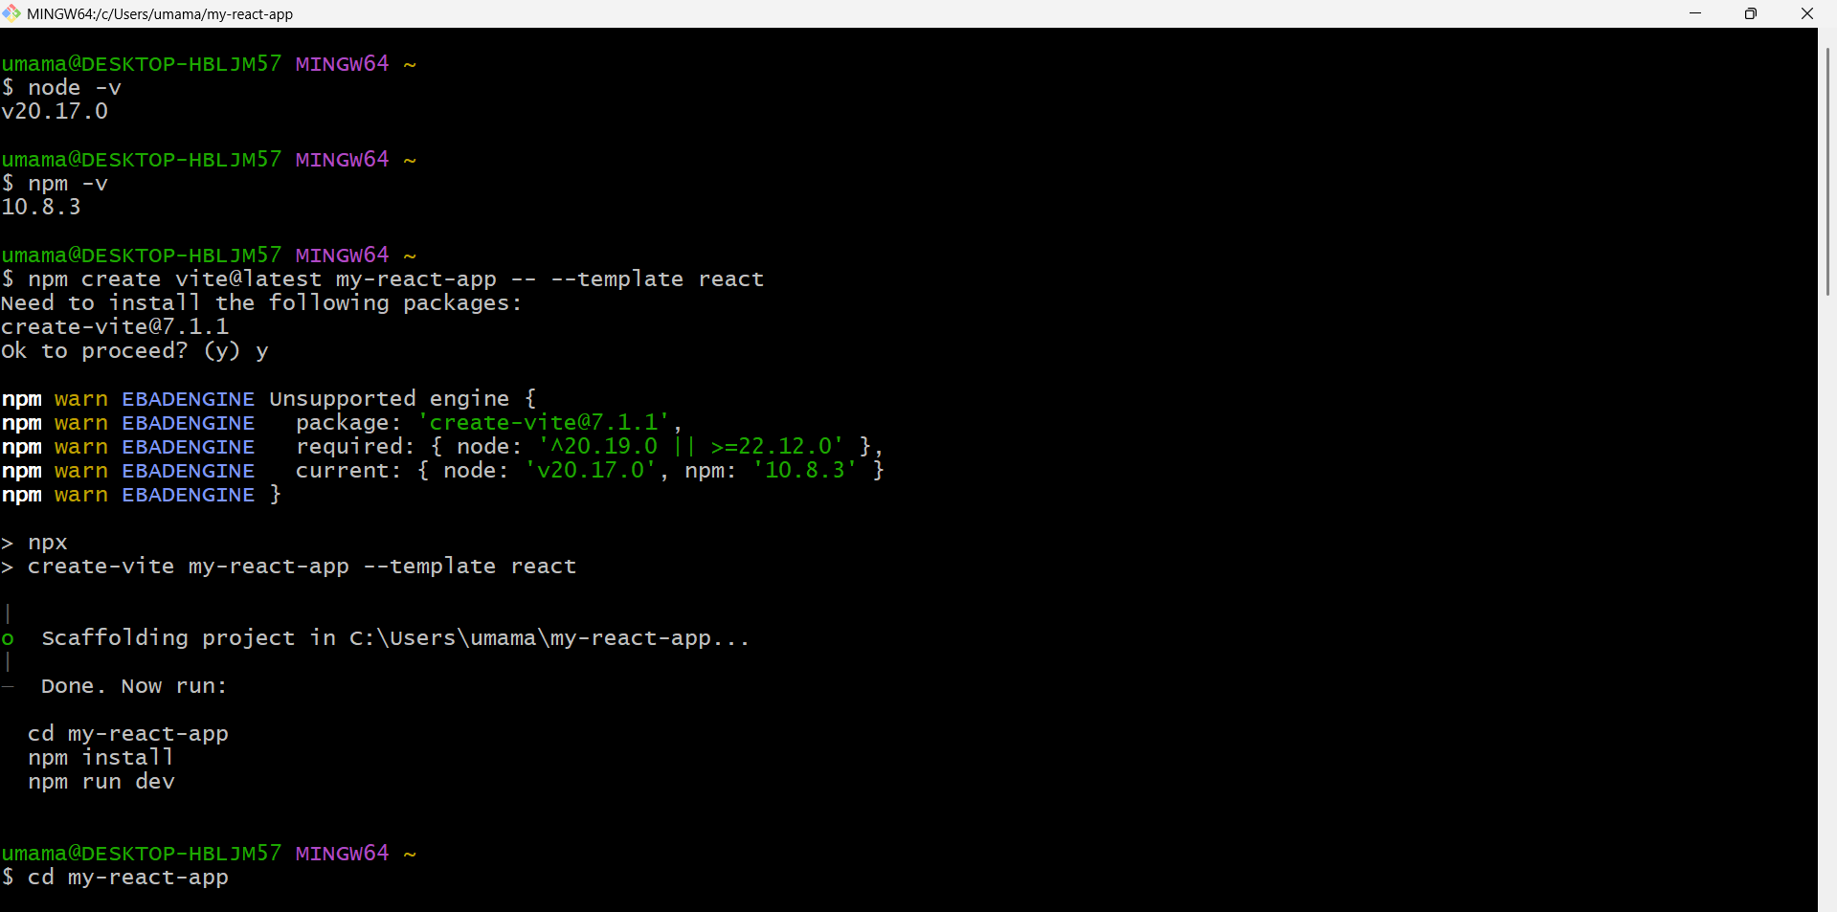

* npm install
* npm i react-router-dom

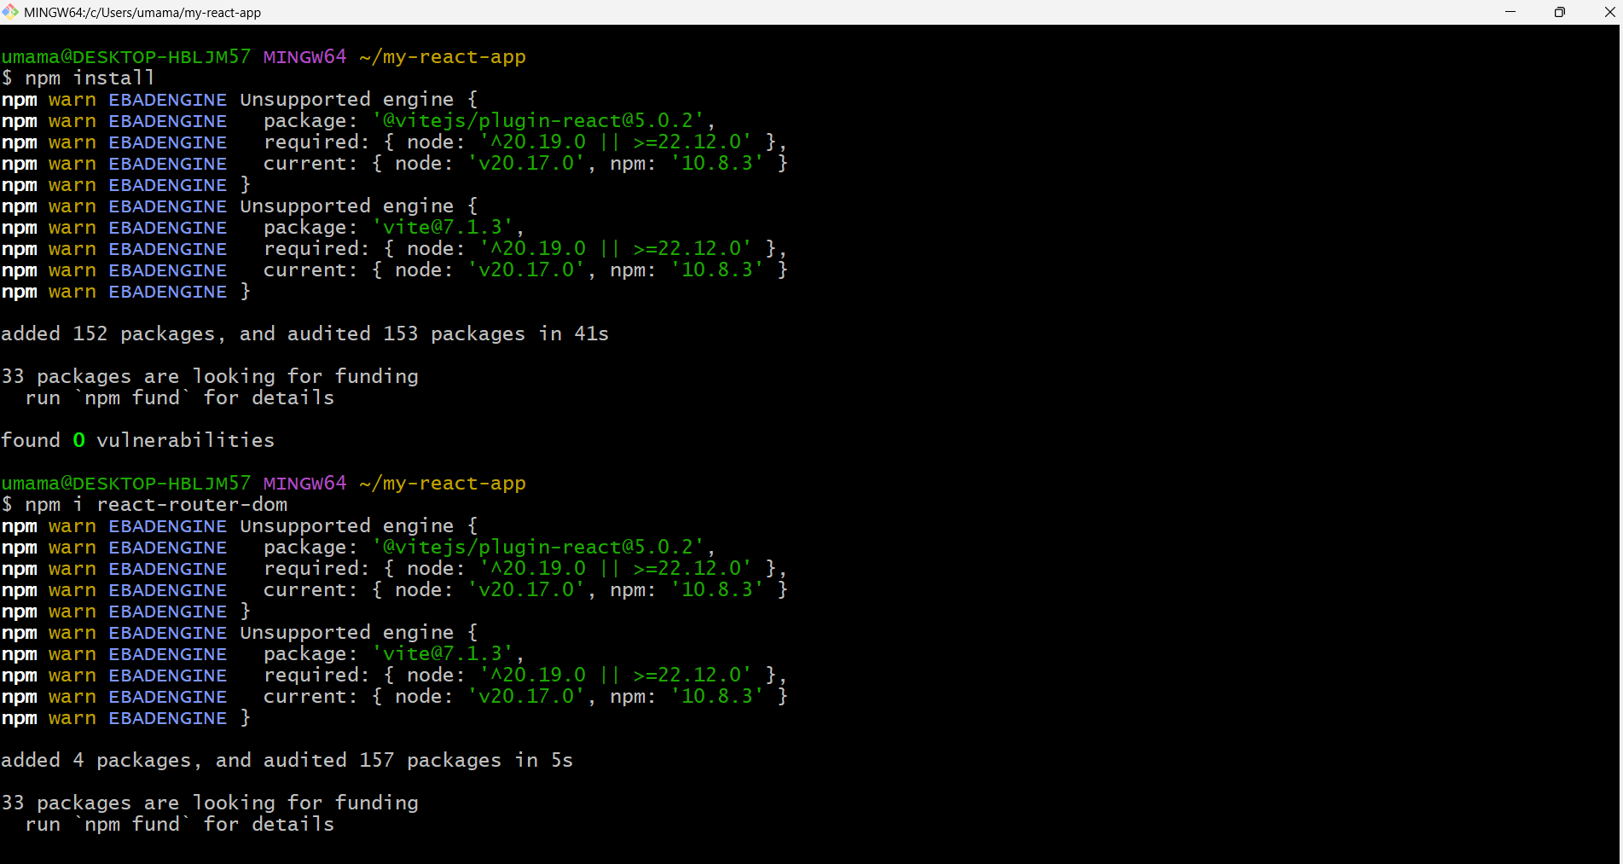

Add lint & test tools: npm install -D eslint vitest @testing-library/react @testing-library/jest-dom

Edit package.json scripts

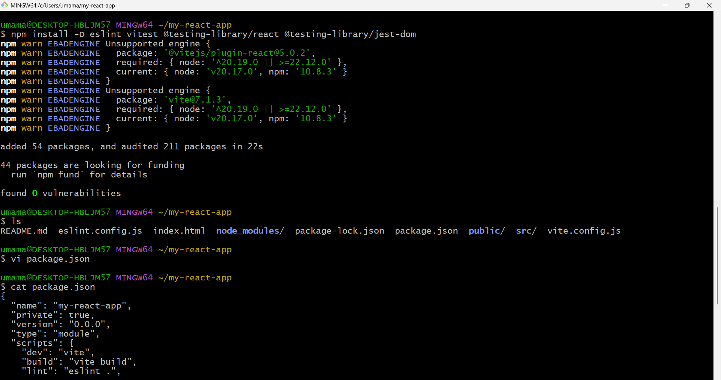

Create these files: src/main.jsx, src/App.jsx, src/components/Header.jsx, src/components/Card.jsx, src/components/Footer.jsx, src/pages/Home.jsx, src/pages/About.jsx, src/pages/Blog.jsx,

We now have at least **three reusable components** (Header, Card, Footer) plus **routing** (react-router-dom).

Local test:

npm run dev # open http://localhost:5173

npm run build # creates dist/ (Vite's build folder)

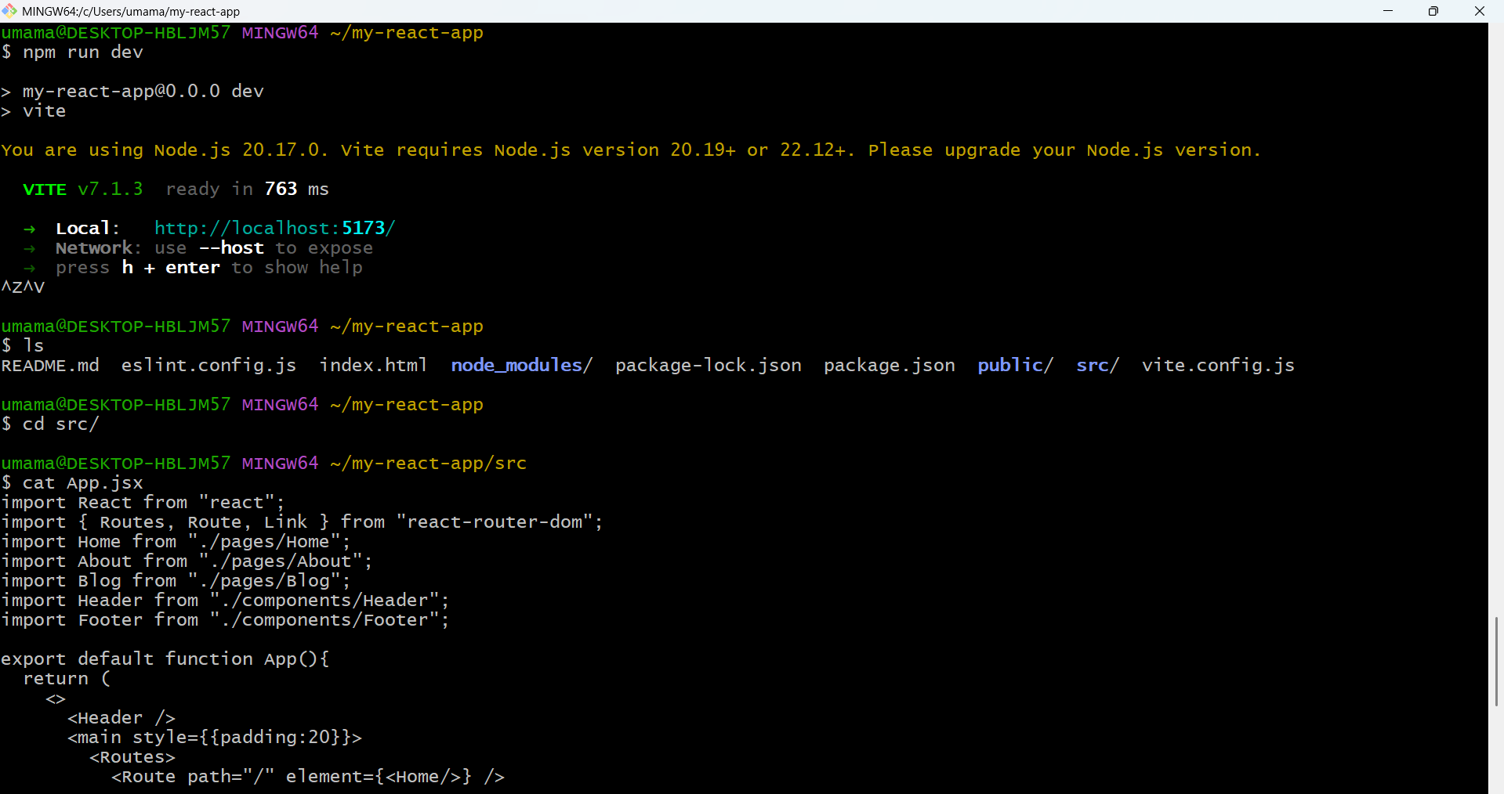

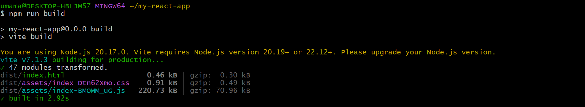

Accessing the file locally

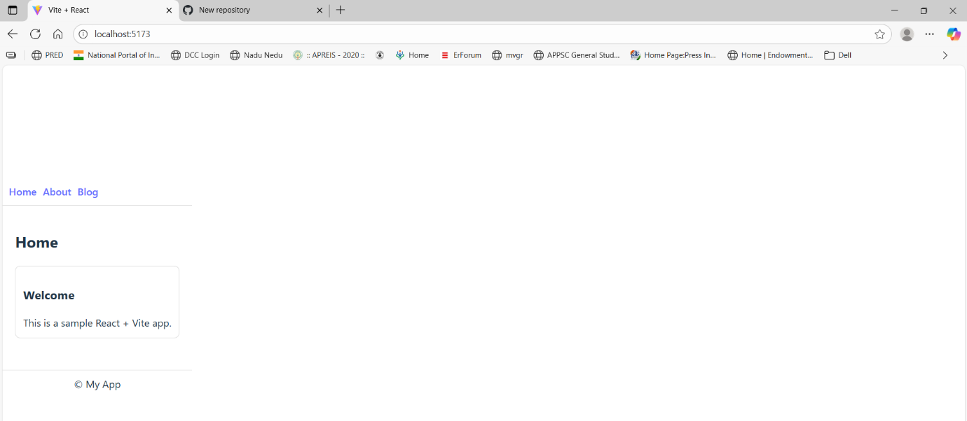

On GitHub: click New repository (top-right, + → New repository).

Name it my-react-app, set Public, don't initialize with README (we already have local files). Click Create repository.

In our project folder (local)

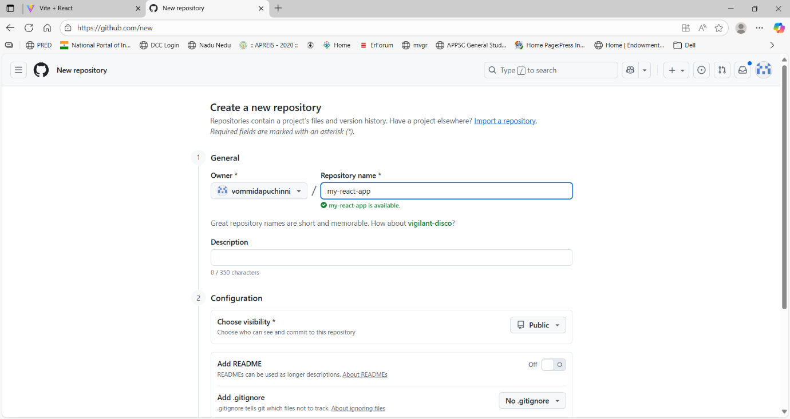

git init

git add .

git commit -m "1st commit"

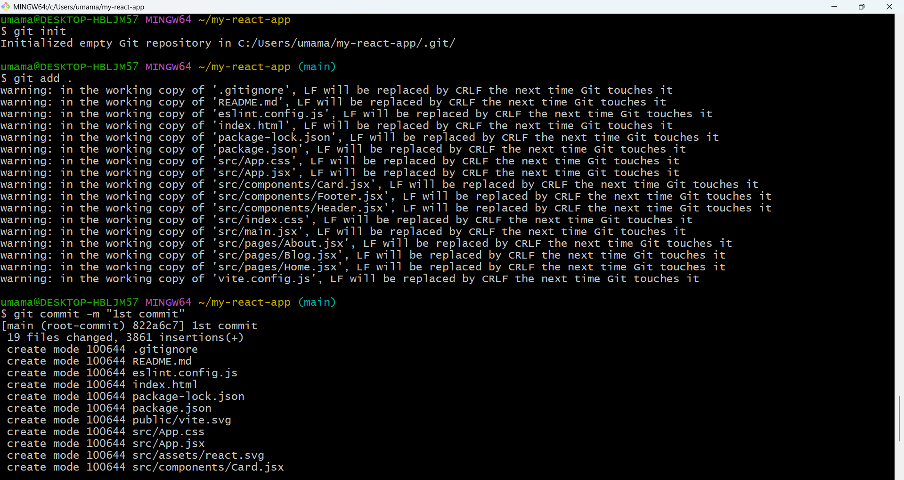

git remote add origin https://github.com/vommidapuchinni/my-react-app.git

git push origin main

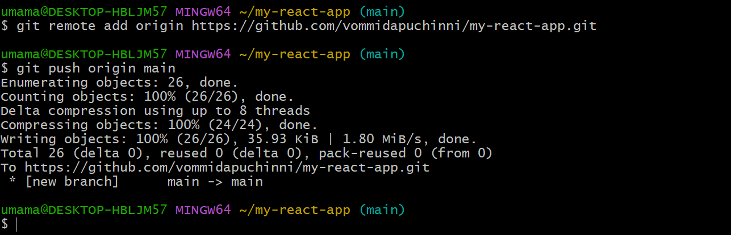

**Create an AWS EC2 Linux server (exact clicks) and security group**

**Goal:** create an Ubuntu instance reachable by SSH (port 22) and HTTP (port 80).

Sign in to AWS Console → top search box type **EC2** → click **EC2** (or from Services → Compute → EC2).

In EC2 Dashboard → left sidebar → **Instances** → **Launch instances** (button).

Launch instance wizard:

* Name: react-deploy-1
* AMI: choose Ubuntu Server 22.04 LTS (HVM), SSD (or 20.04 LTS)

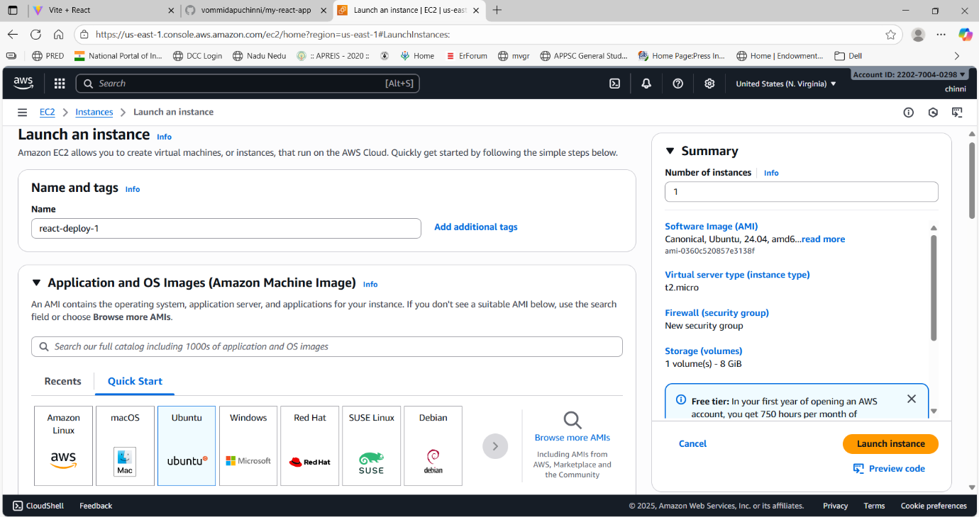

* Instance type: t2.micro (free tier eligible)
* Key pair (login): Create a new key pair → name it react-key → Download .pem file and keep it safe (you’ll use it to SSH).

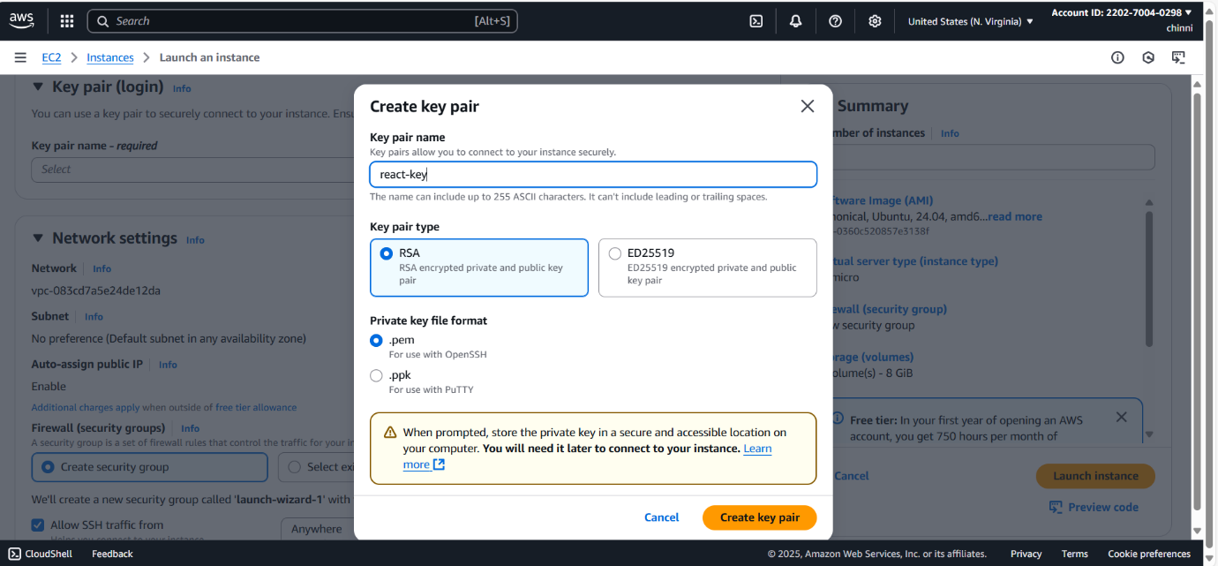

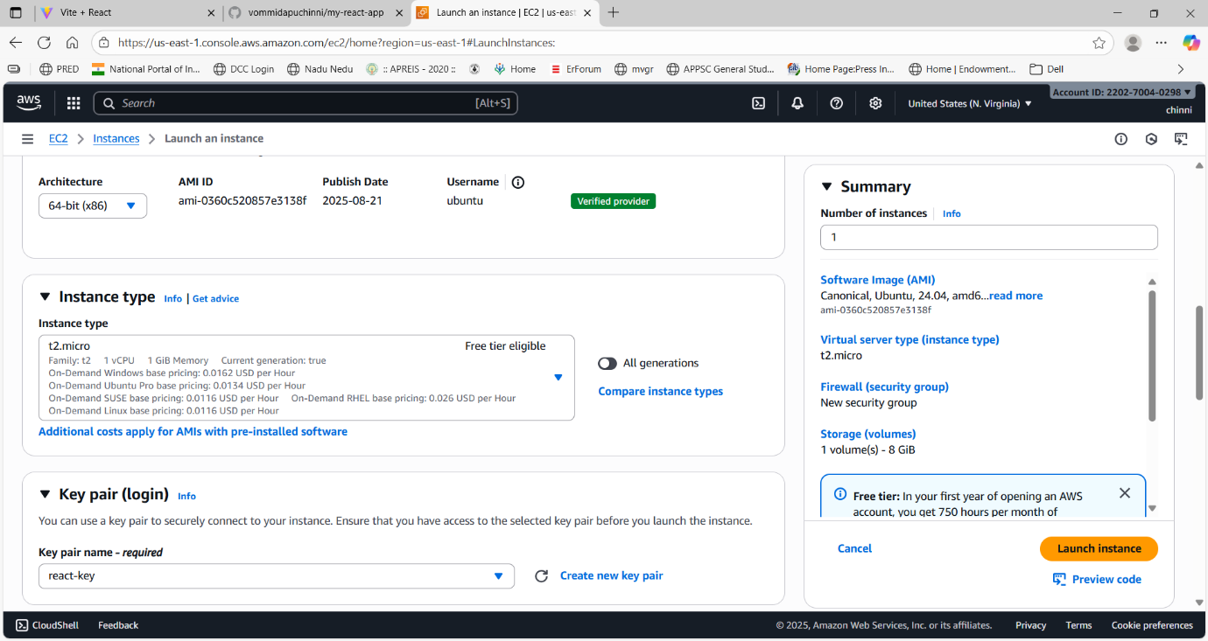

* Network settings (Security group): Create new security group with rules:
  + SSH (port 22) — Source: My IP (recommended) or your IP range
  + HTTP (port 80) — Source: Anywhere (0.0.0.0/0) (to allow web traffic)
  + Allow port 3000
* Click Launch instance.

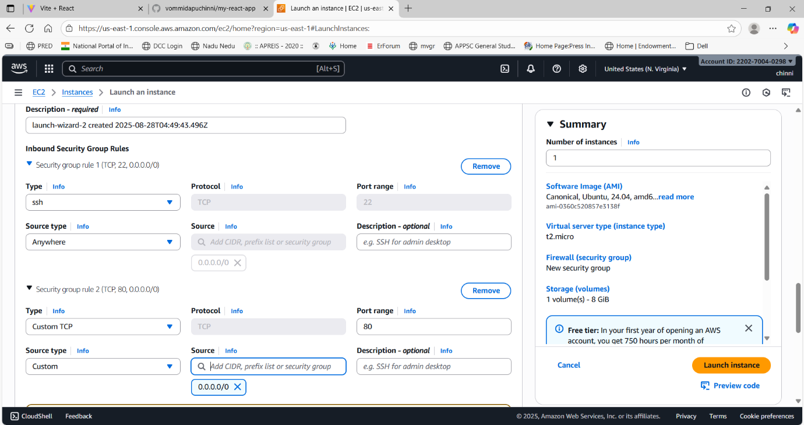

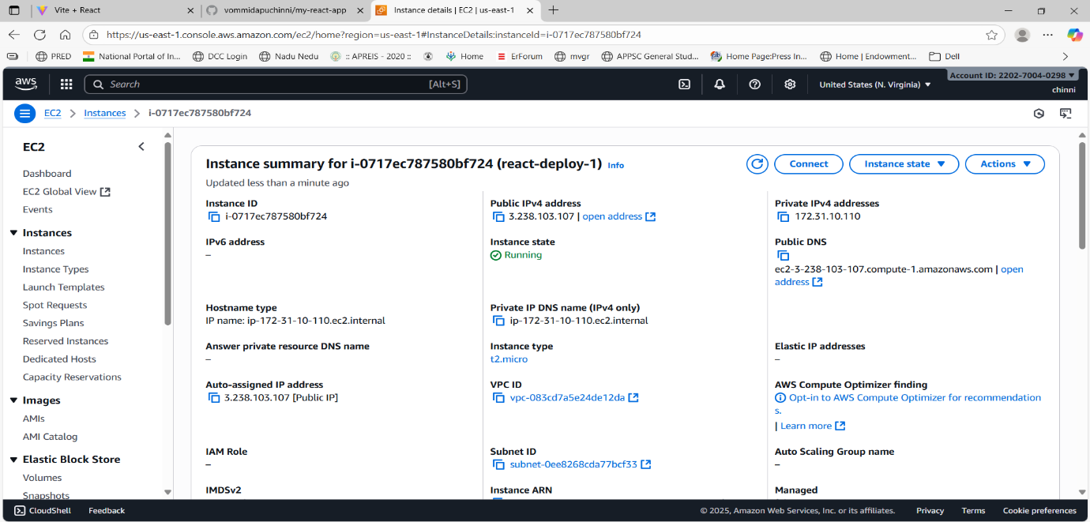

Prepare the server

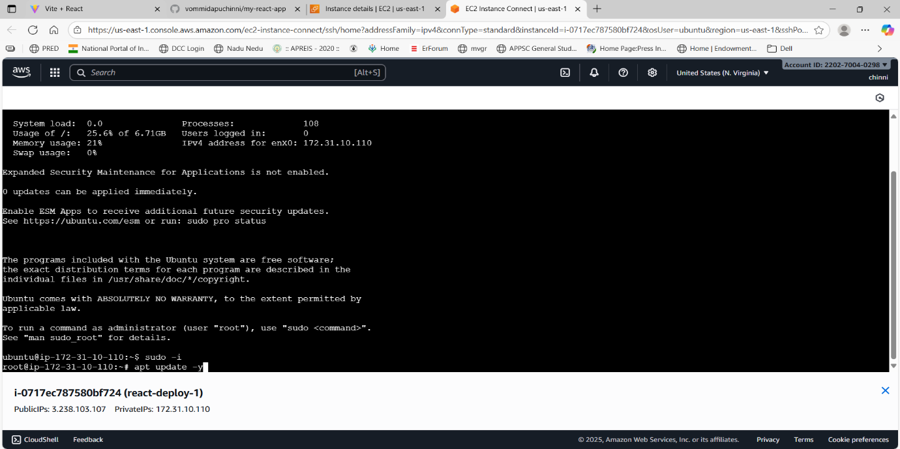

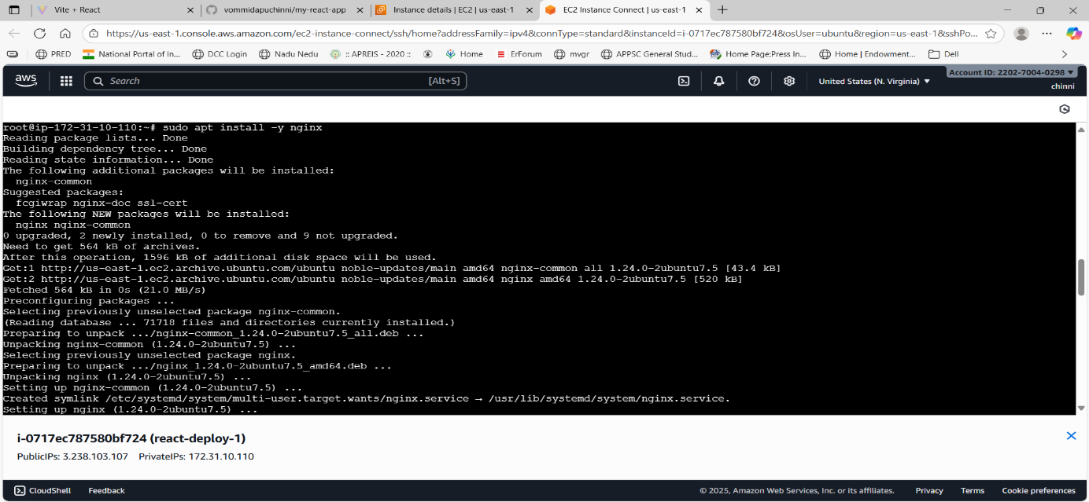

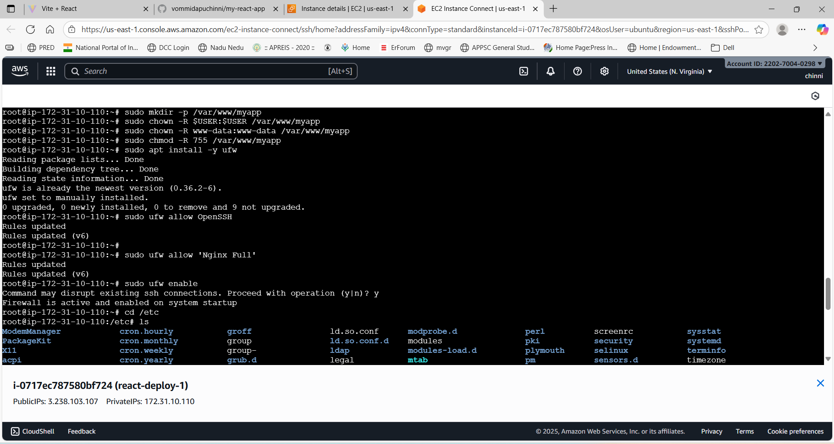

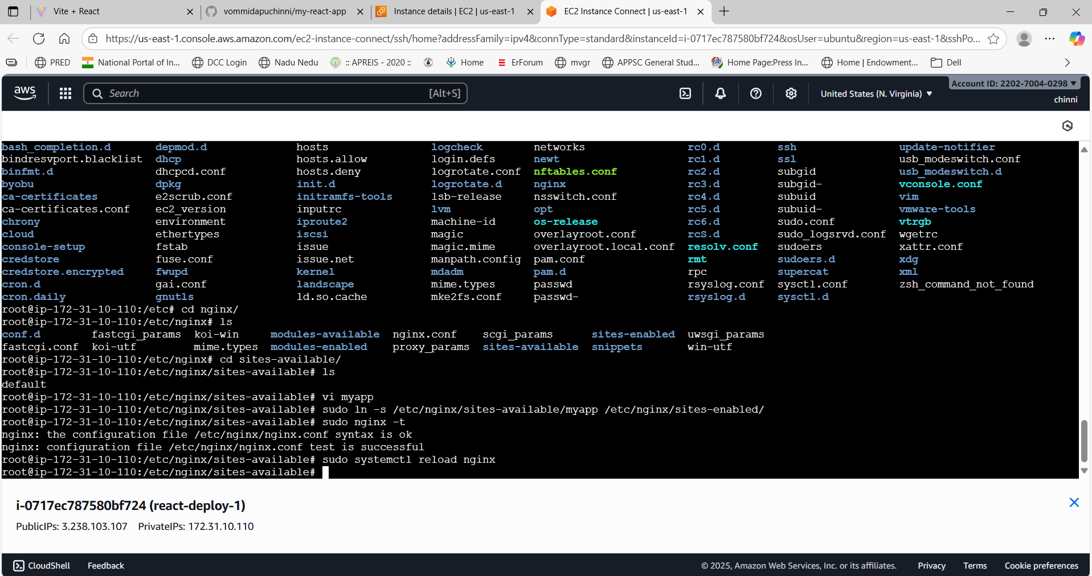

**On GitHub (UI steps)**:

* Open your repo → Settings → Secrets and variables → Actions → New repository secret.
* Add secret SSH_PRIVATE_KEY — paste the content of downloaded key
* Add secret SERVER_IP — your EC2 IP.
* Add secret SERVER_USER — ubuntu (for Ubuntu AMI).
* Add secret DEPLOY_PATH — /var/www/myapp

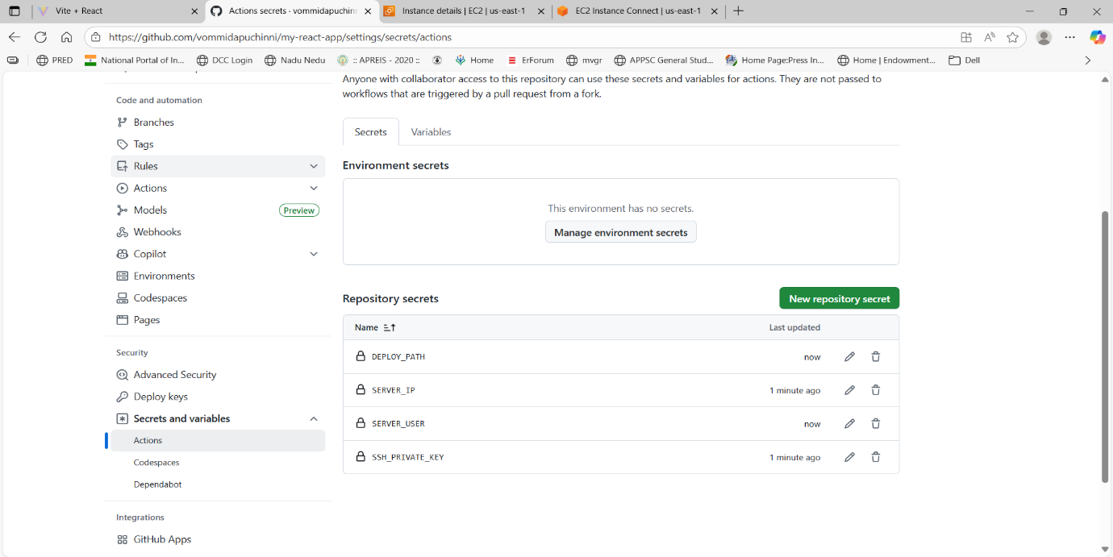

**Create deploy.yaml file and pull to github**

**Explanation of github CI/CD:**

* npm ci installs deterministically.
* npm run lint and npm run test are your CI quality gates.
* npm run build produces static assets (dist/ for Vite, build/ for CRA). The workflow checks for both.
* webfactory/ssh-agent loads the SSH_PRIVATE_KEY so rsync/ssh can connect to your EC2.
* rsync --delete synchronizes the build folder to the server folder and deletes removed files.
* After copying, we chown to www-data (nginx user) and reload nginx.

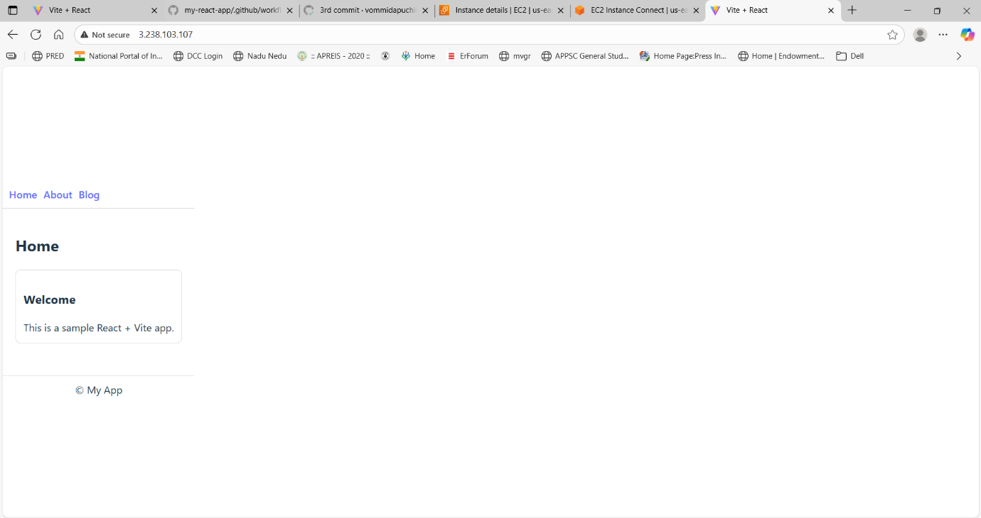

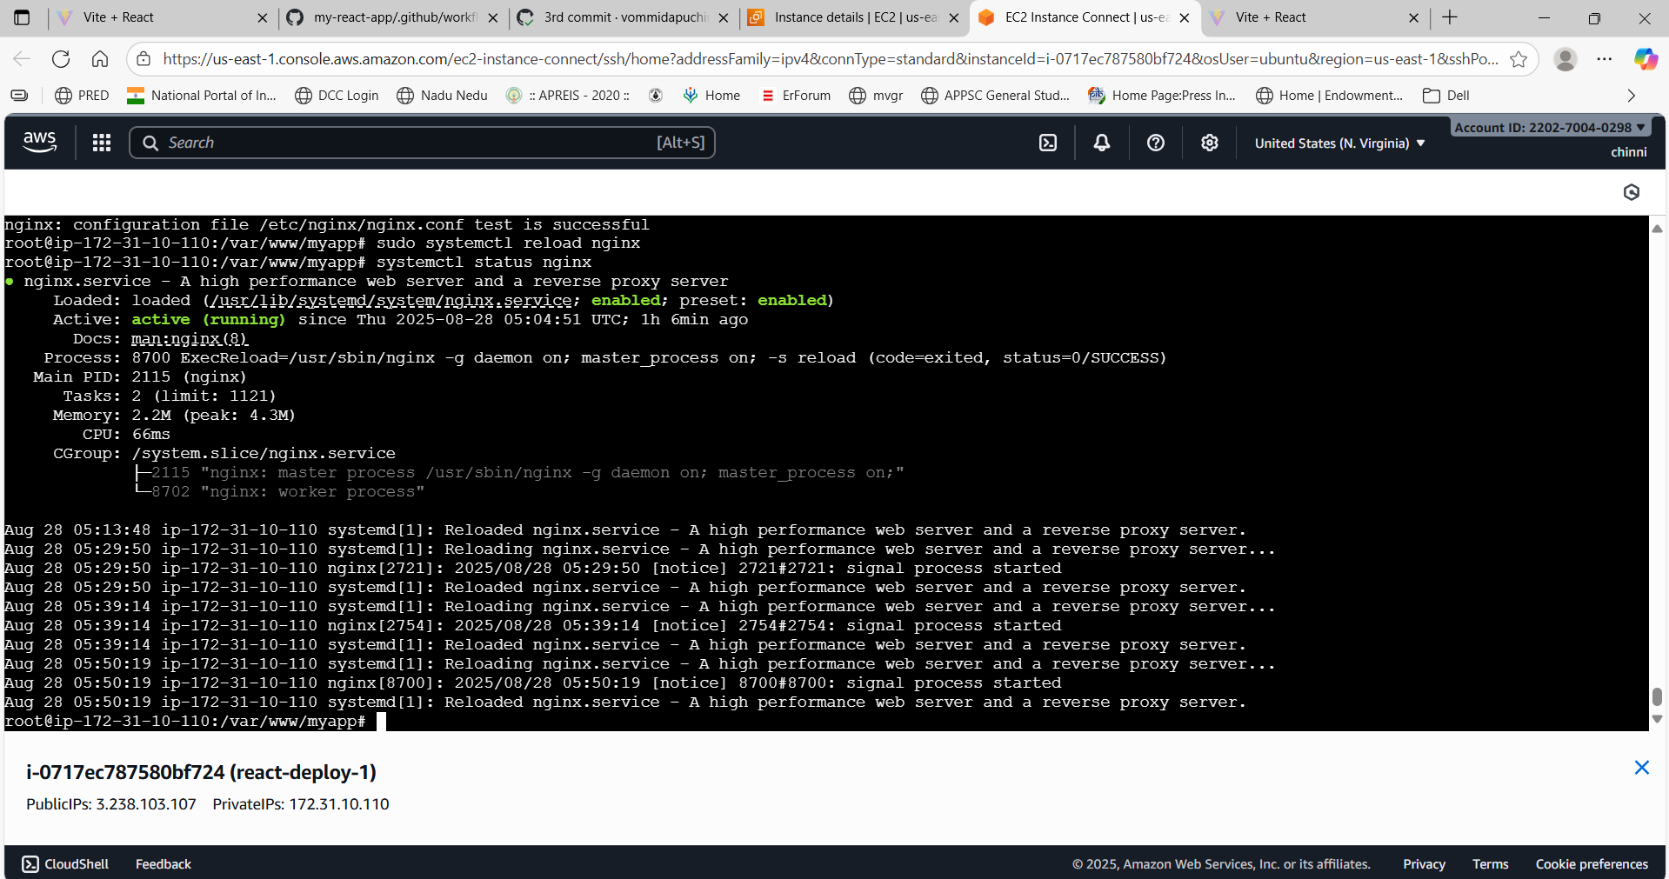

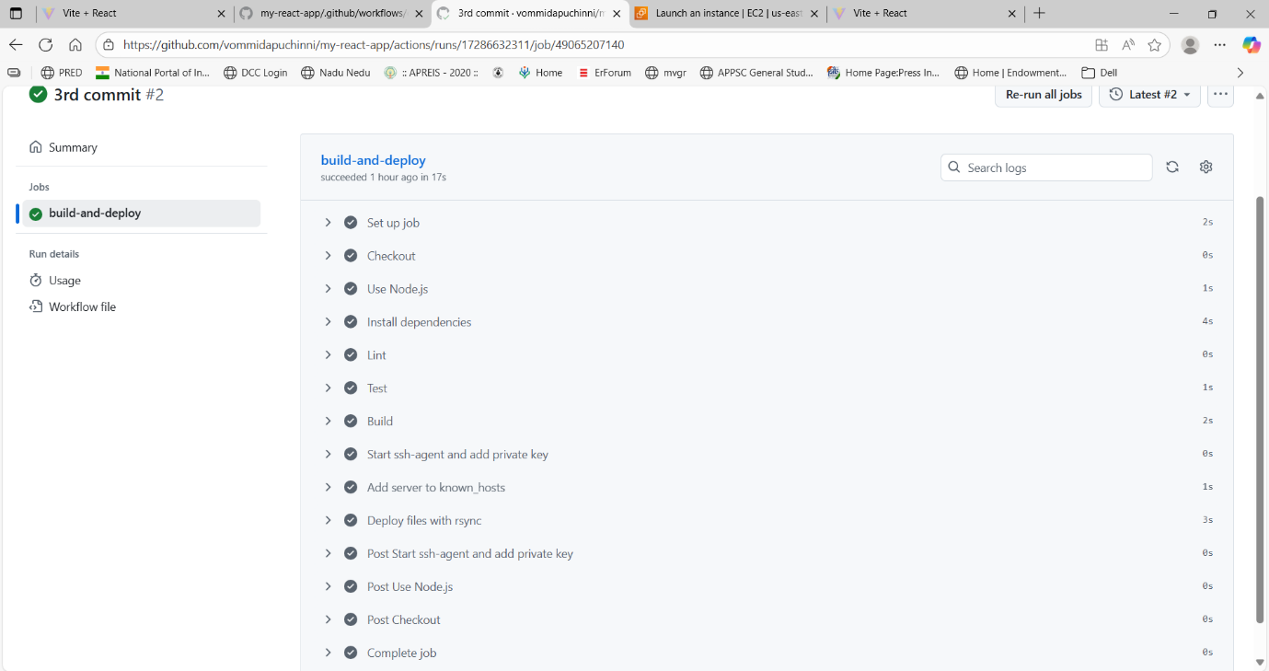

**Dockerize React App + Deploy via CI/CD**

**Create Dockerfile for React App**

In our React project root, create a file named **Dockerfile**:

* Node builds the React app → produces static files in build/.
* Nginx serves those static files efficiently.

**Create docker-compose.yml**

If you want easier management and future scaling

Build Docker Image locally: docker-compose up -d –build

* Docker will build and copy /app/dist to Nginx.
* After it finishes, check containers:

For locally createing we need to connect to docker desktop. Check docker version.

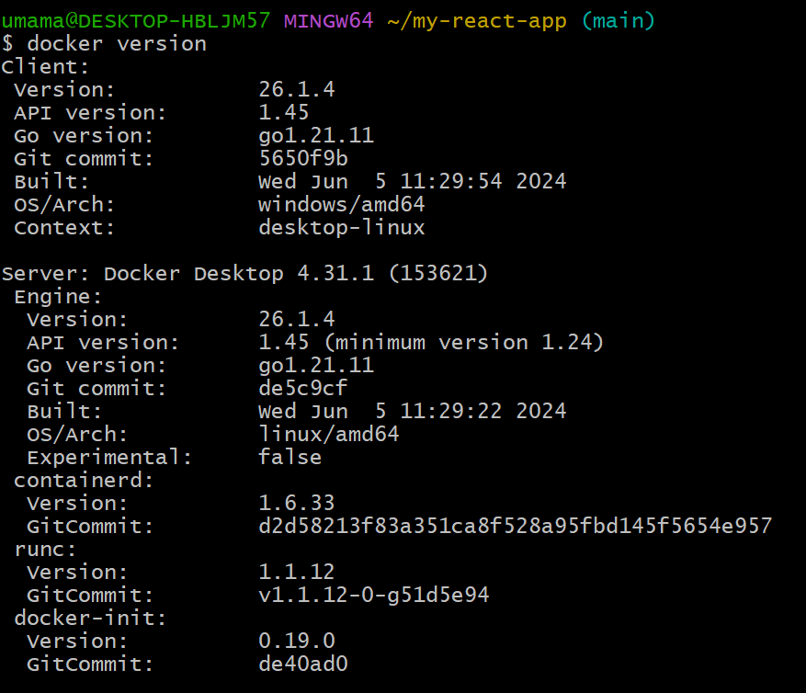

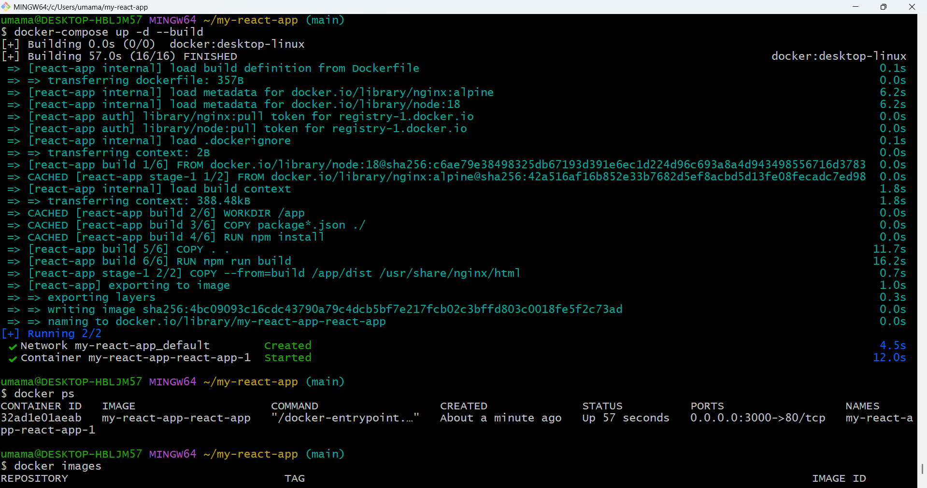

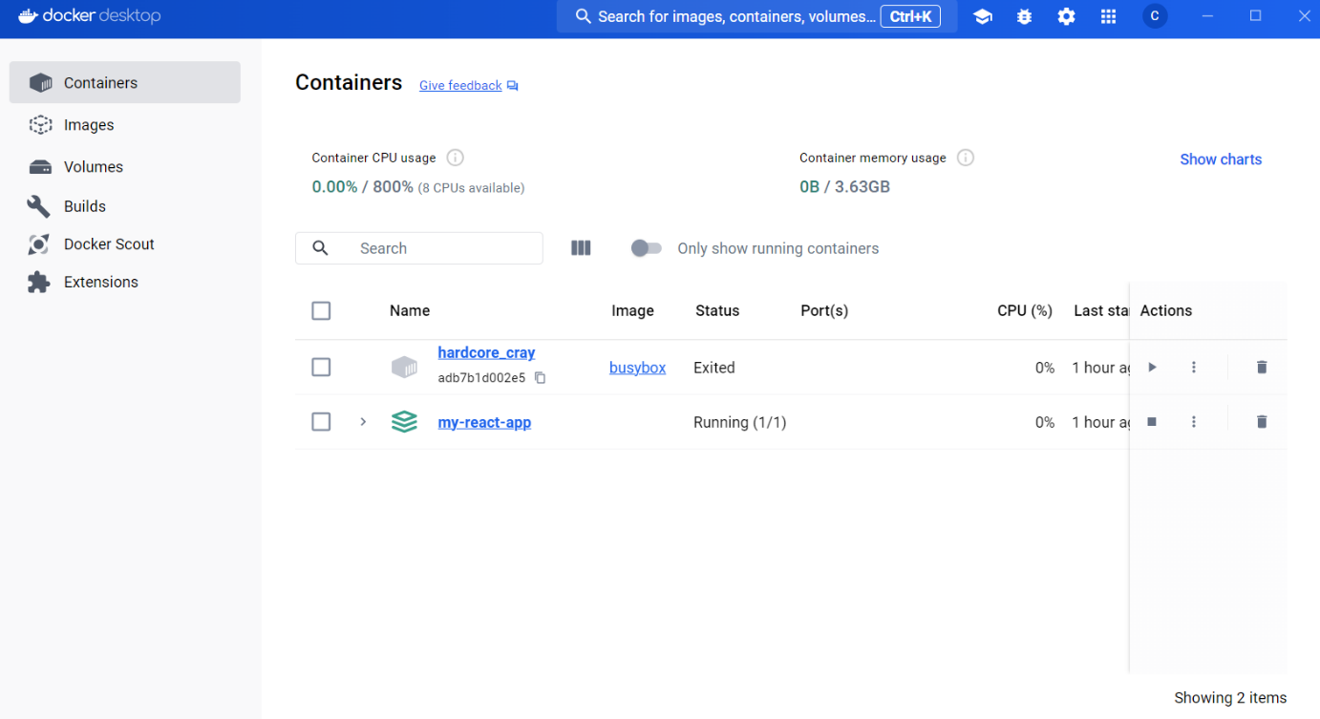

docker ps we see container is running

**Test React App**

Open browser → http://localhost:3000 → React app should load.

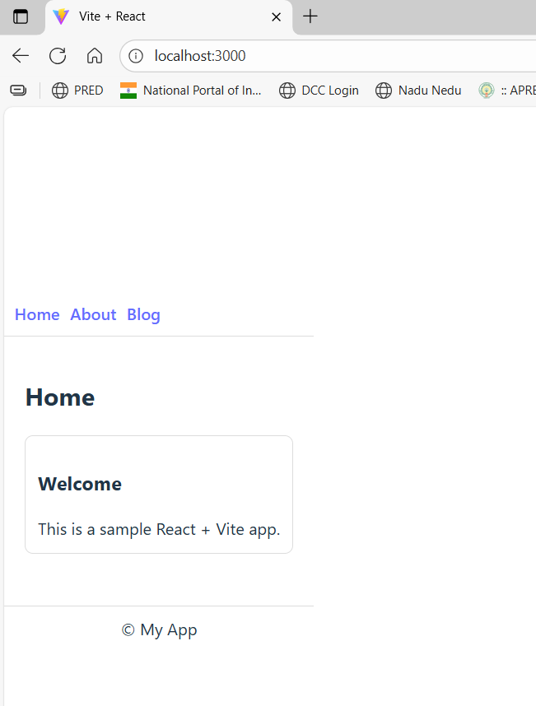

**Production environment:**

For pushing and pulling to ec2 in aws. Before we created ec2 that is used for production environment. Before we deployed that will be removed

In that instance install docker and docker-compose

* Update packages: sudo apt update && sudo apt upgrade -y
* Install Docker: sudo apt install -y docker.io
* Start Docker and enable at boot: sudo systemctl start docker& sudo systemctl enable docker
* Add your user to Docker group (optional, allows running docker without sudo):sudo usermod -aG docker $USER
* Install Docker Compose: sudo apt install -y docker-compose

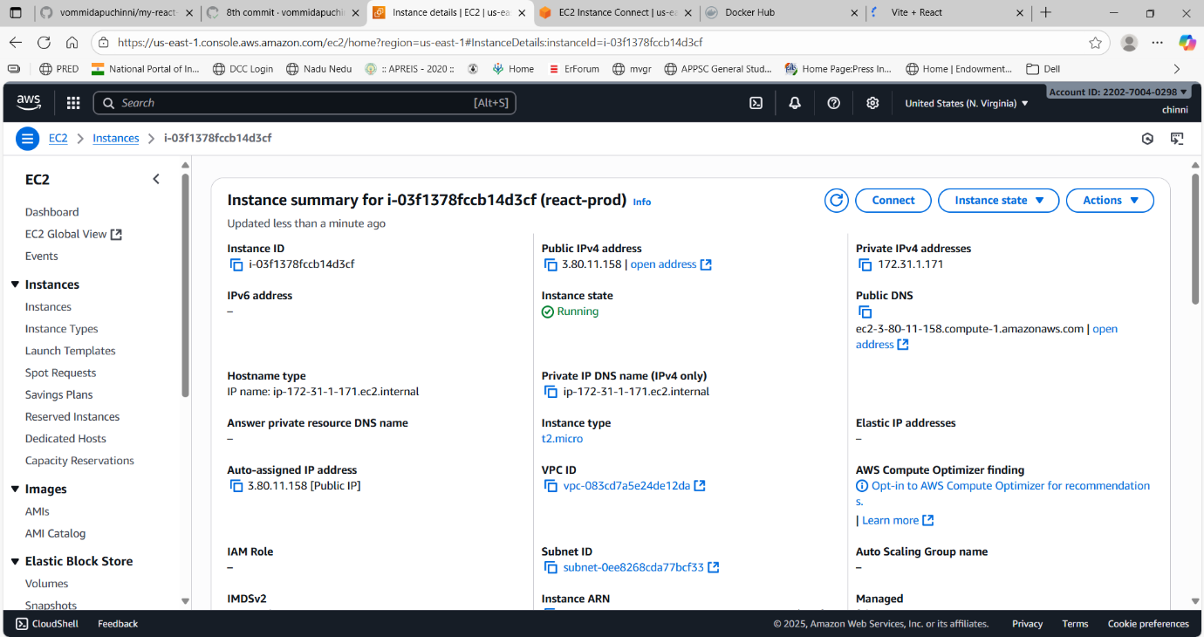

Go to your GitHub repo → **Settings → Secrets → Actions → New repository secret**

Name it, for example: EC2_IP

Value: your EC2 public IP (e.g., 3.80.11.158)

Save the secret

**Created deploy-prod.yaml file and push to github**

* Push this updated workflow to GitHub.
* Trigger a push to main.
* The workflow will:
* SSH to EC2
* Remove any old folder
* Clone repo fresh
* Run Docker → container starts
* Your app will be live at http://EC2_IP:3000

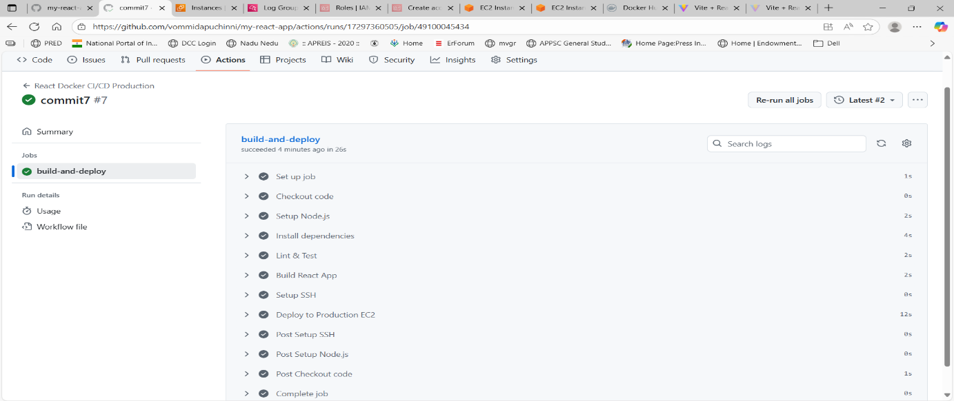

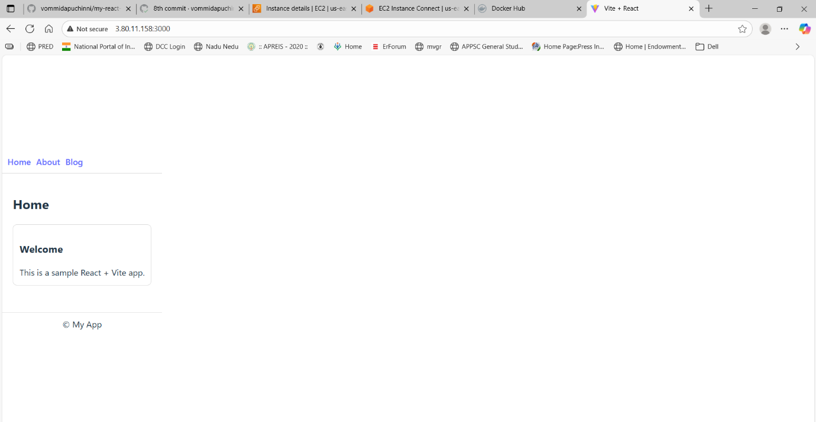

We can see the container running in ec2

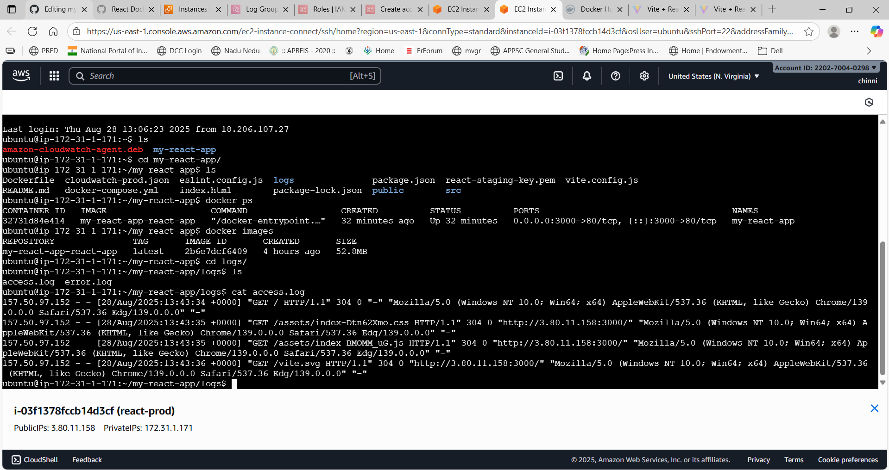

**Staging environment:**

For this env we create separate branch

Push Staging Branch to GitHub: git checkout -b staging

We use separate docker-compose.yaml and deploy-staging.yaml files

Staging docker-compose-staging.yml (port 4000 → 80 inside container)

For this created another EC2 instance

In EC2 Dashboard → left sidebar → **Instances** → **Launch instances** (button).

Launch instance wizard:

* Name: react-staging
* AMI: choose Ubuntu Server 22.04 LTS (HVM), SSD (or 20.04 LTS)

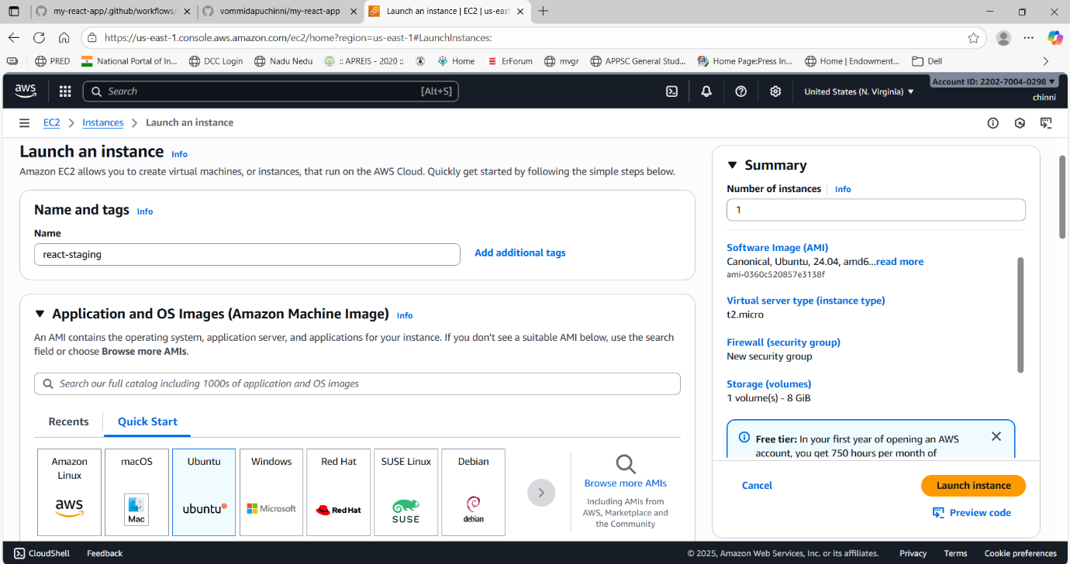

* Instance type: t2.micro (free tier eligible)
* Key pair (login): Create a new key pair → name it react-staging-key → Download .pem file and keep it safe (you’ll use it to SSH).

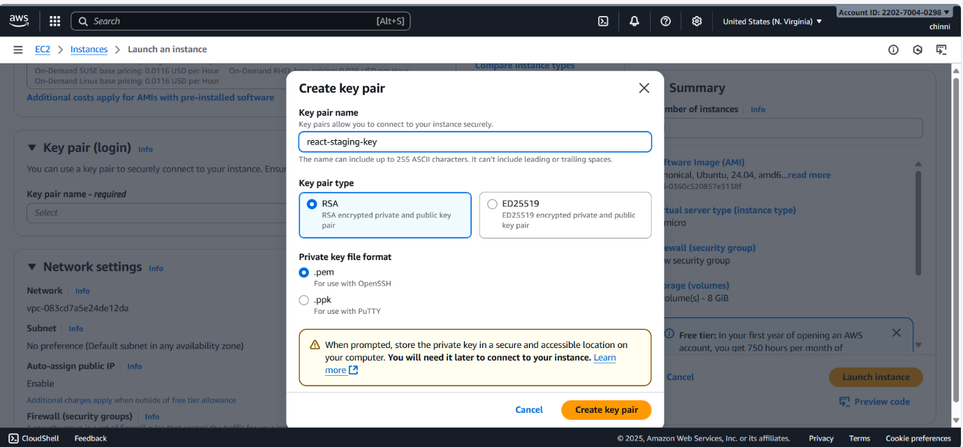

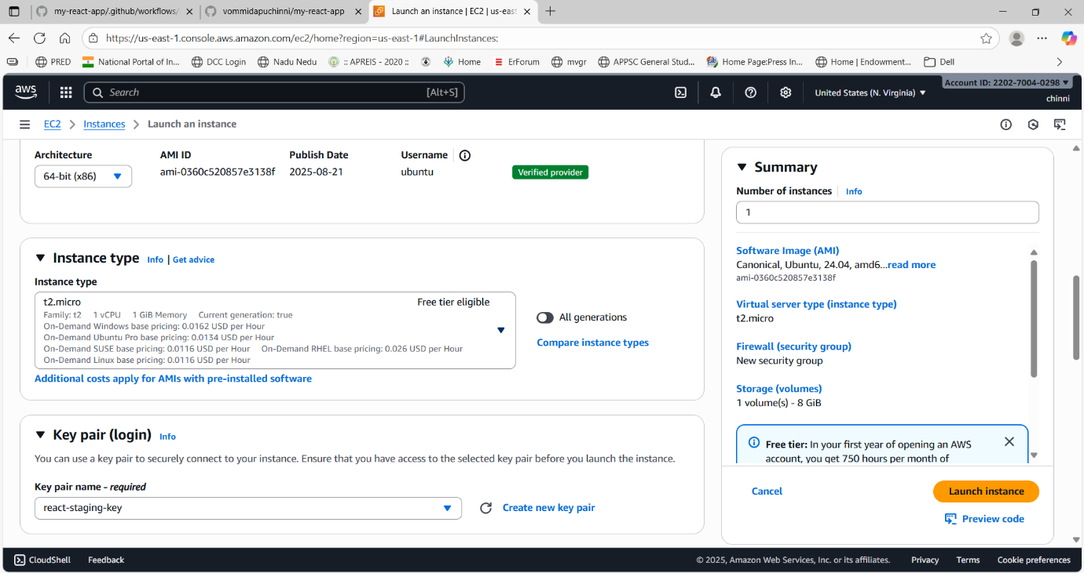

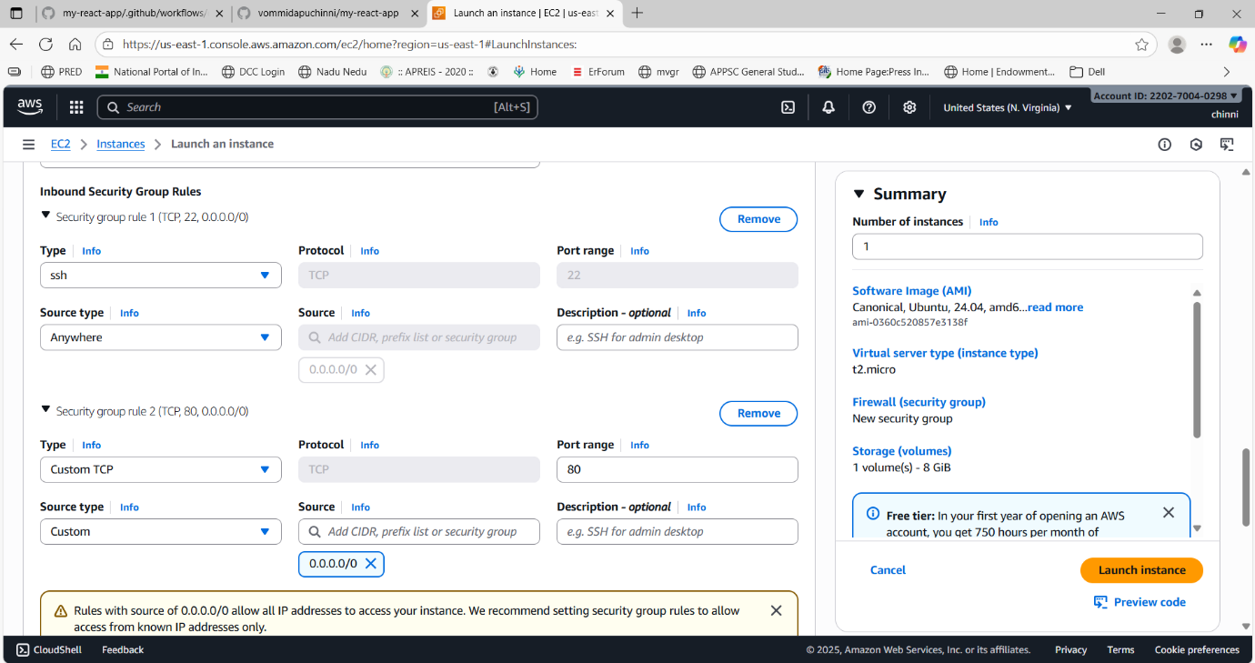

* Network settings (Security group): Create new security group with rules:
  + SSH (port 22) — Source: My IP (recommended) or your IP range
  + HTTP (port 80) — Source: Anywhere (0.0.0.0/0) (to allow web traffic)
  + Allow port 4000
* Click Launch instance.

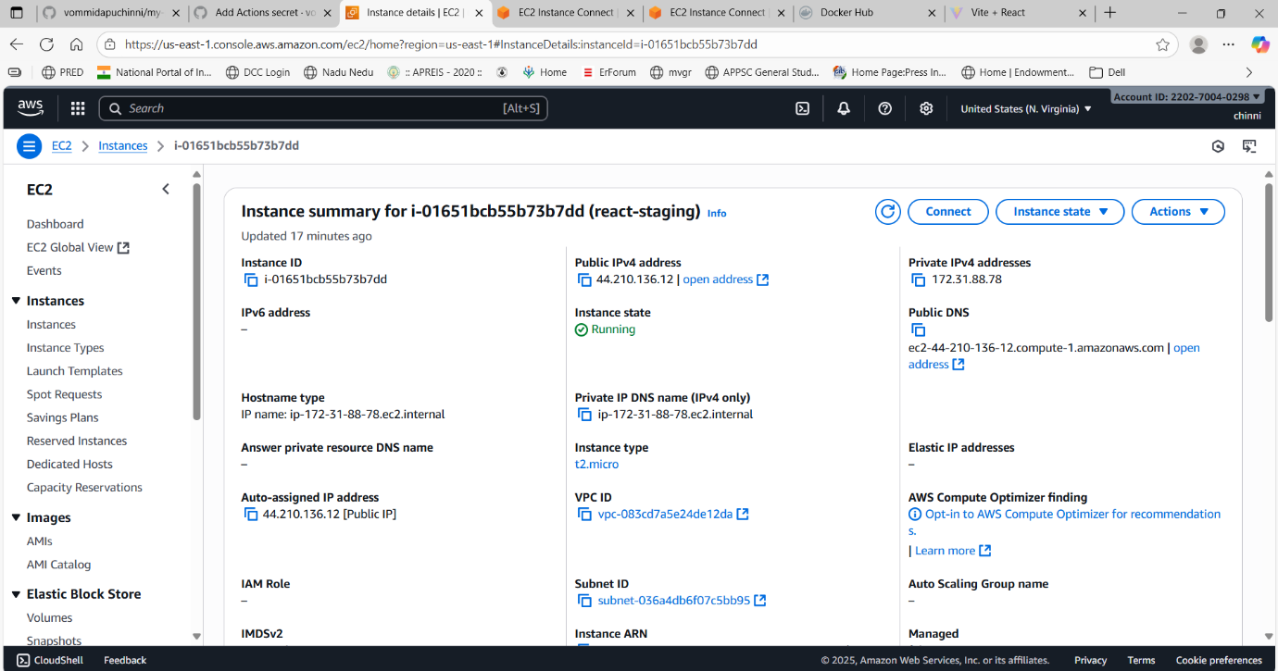

CloudWatch Works with Roles

* Create a role with **CloudWatchAgentServerPolicy**.
* Attach it to your EC2 instance.
* The agent automatically has permission — no credentials in JSON needed.

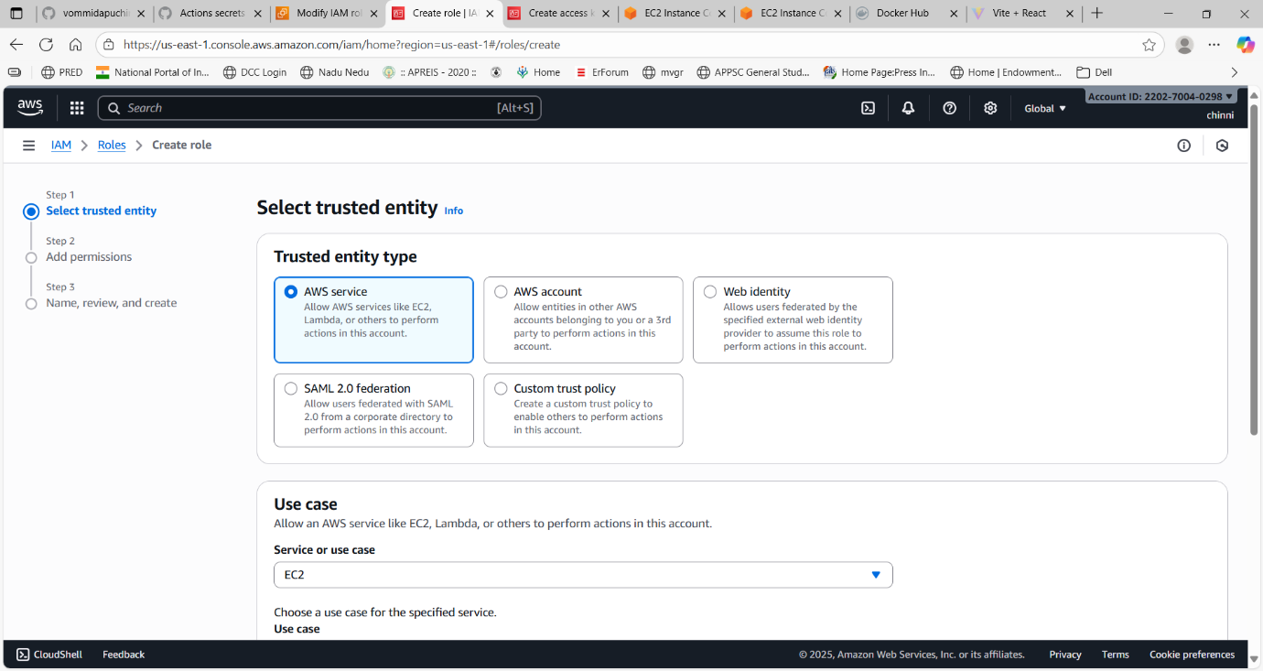

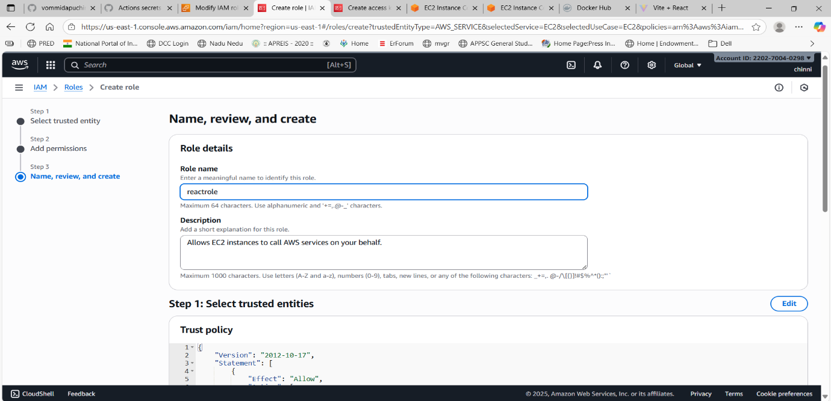

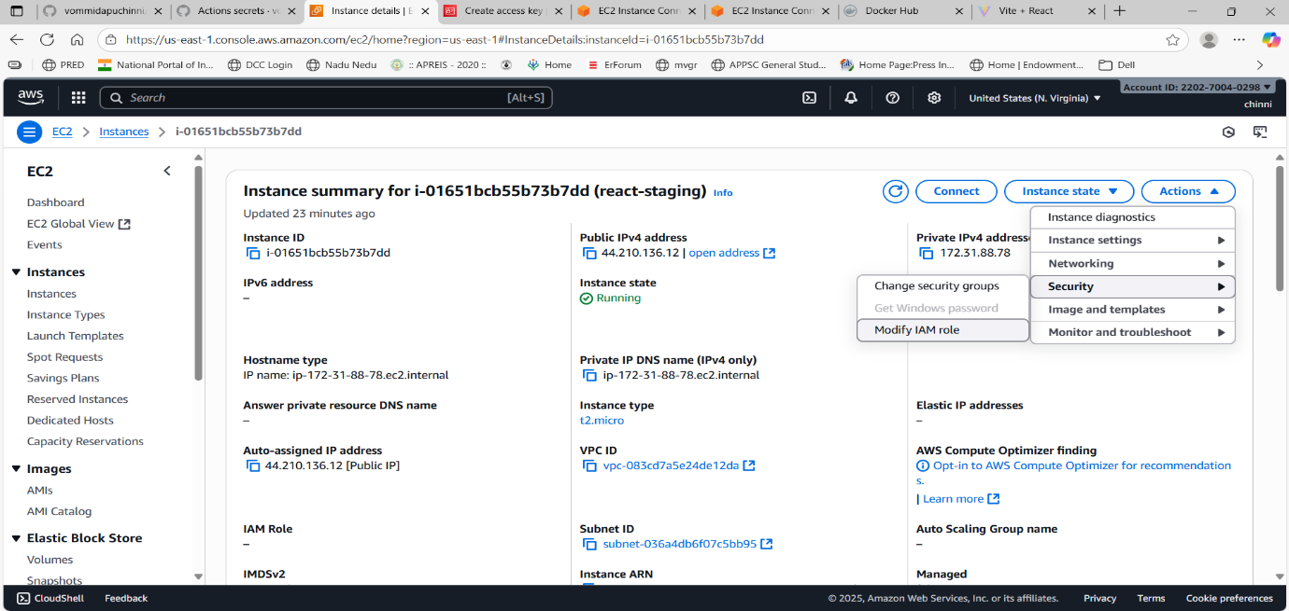

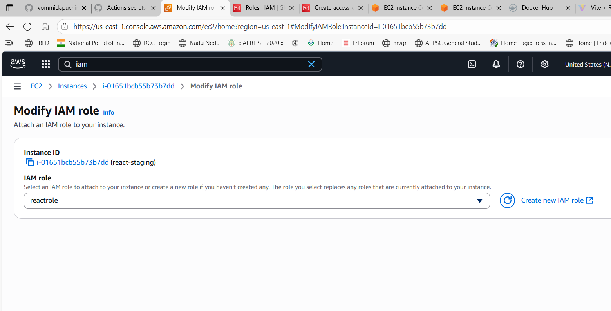

cloudwatch-staging.json created in root folder.

Start CloudWatch Agent : install cloud watch agent locally  
sudo amazon-cloudwatch-agent-ctl -a fetch-config -m ec2 -c file:/home/ubuntu/my-react-app-staging/cloudwatch-staging.json -s

This will **start the agent** using the IAM role.

You can check status: amazon-cloudwatch-agent-ctl -a status

Created user and created keys for it and kept in github secrets

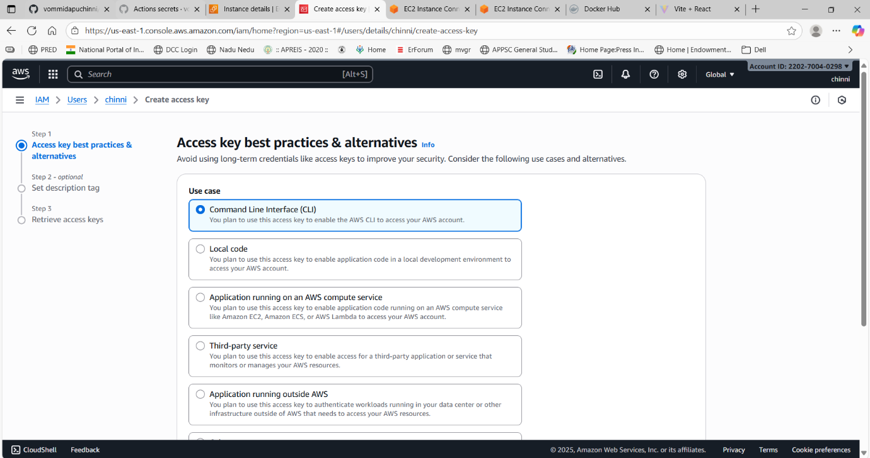

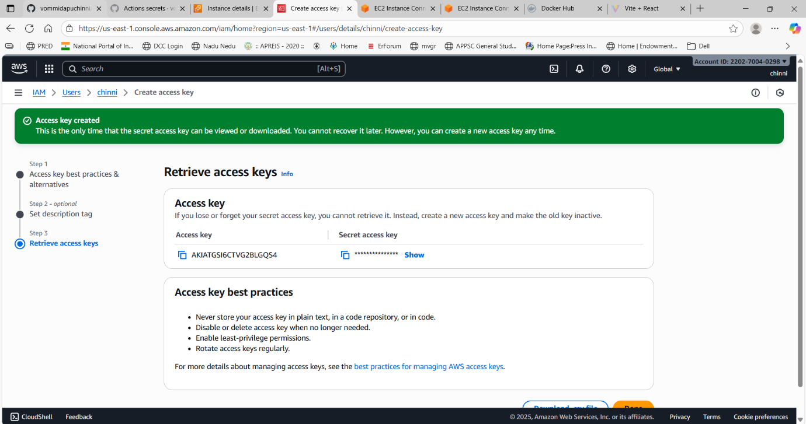

workflow

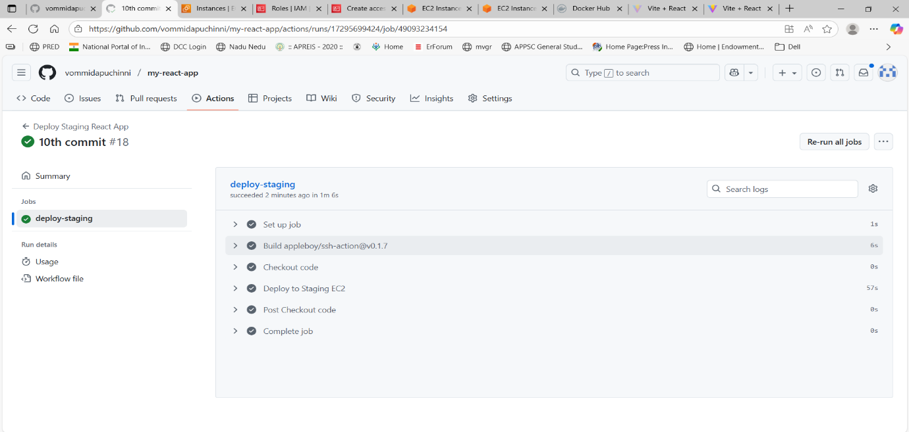

Accessed with ip

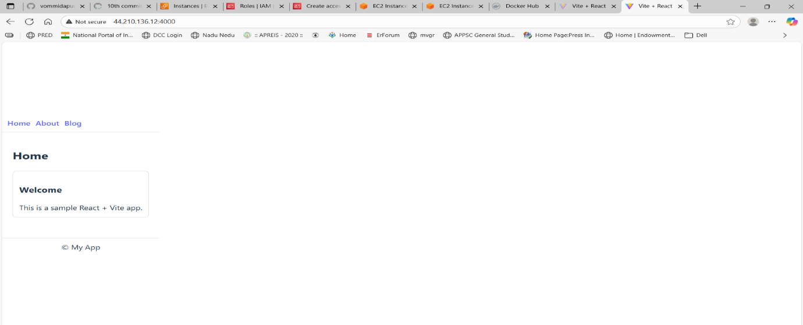

Cloud watch log groups

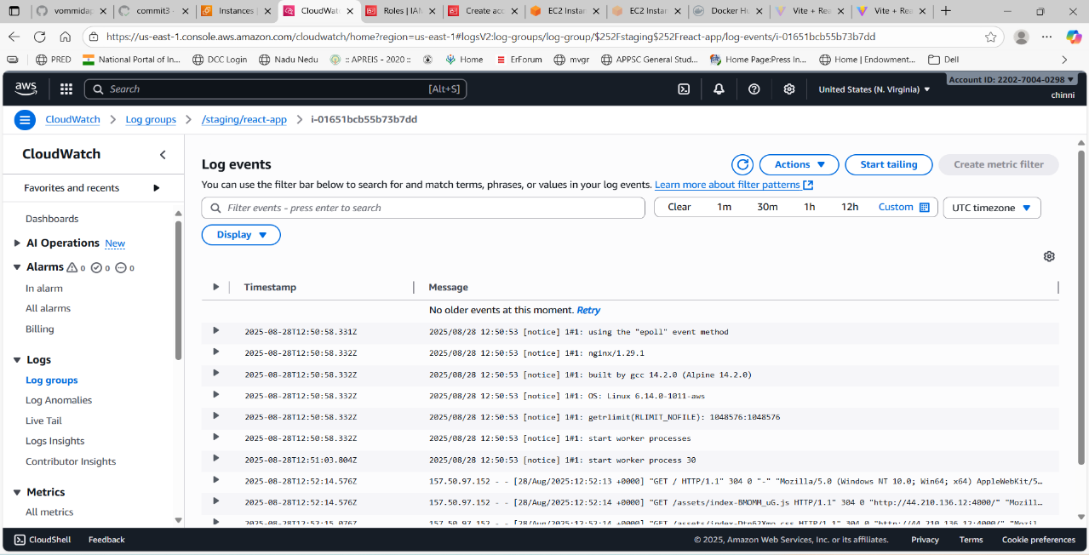

For production I did not kept cloud watch log group for that I am doing I have attached role to ec2 instance and created cloud watch log group and given loggroup folder in docker compose files in productions and pushed to github

Create CloudWatch Configuration for Production: cloudwatch-prod.json

Update Production Docker Compose

**Update Production CI/CD Pipeline**

Add **CloudWatch agent start command** to your production deploy YAML

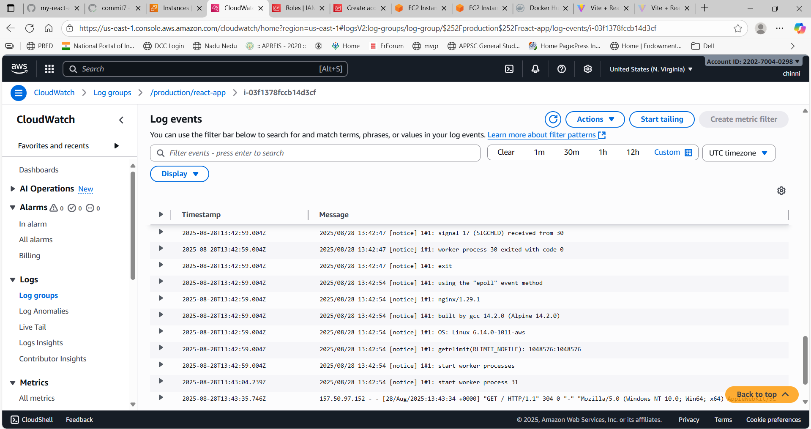



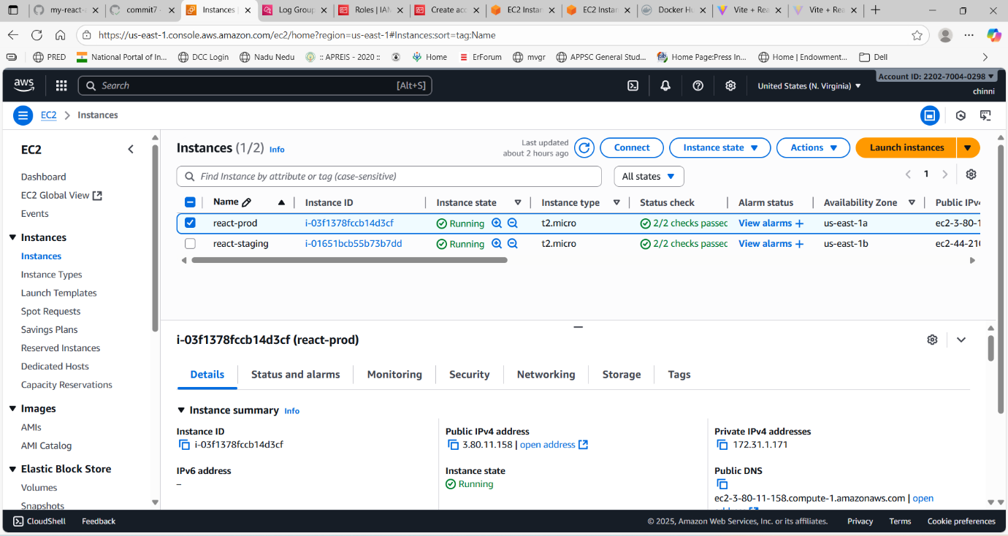

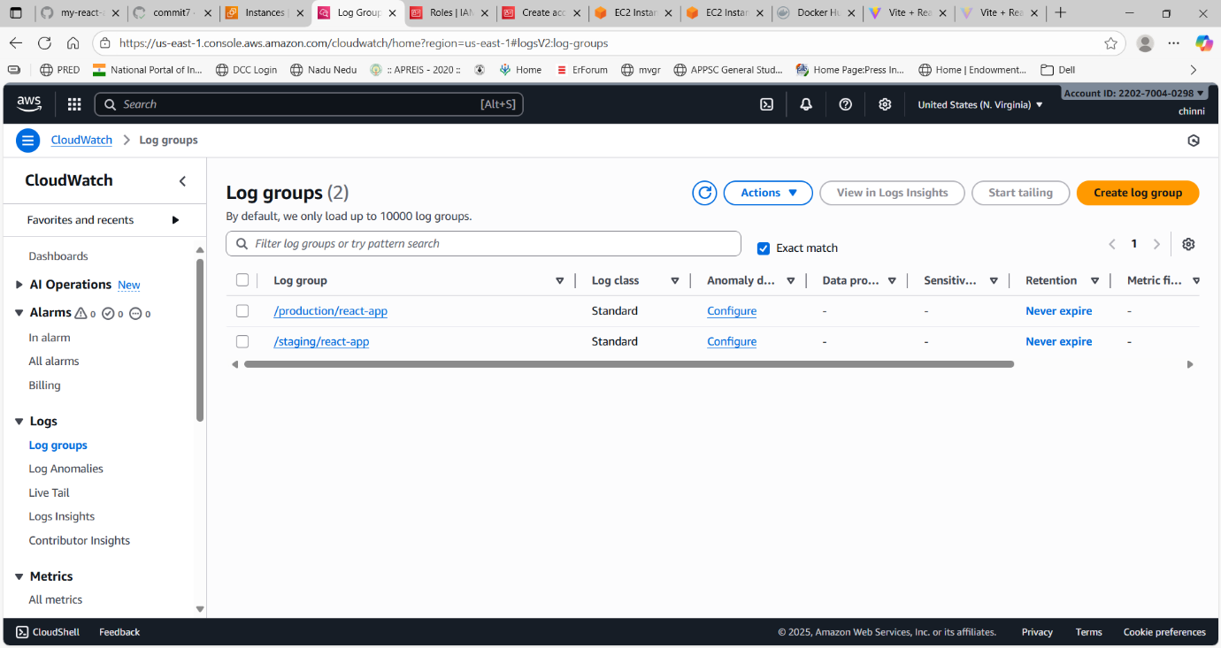

want to **host our React app locally on our machine** and also make it **live on GitHub Pages**

**Prepare our React app for GitHub Pages:** Open our package.json and add the homepage field at the top level

**Next Steps to Deploy on GitHub Pages: Switch BrowserRouter to HashRouter in main.jsx**

Install gh-pages: npm install --save-dev gh-pages

Build and Deploy: npm run predeploy # Creates production build in dist/

npm run deploy # Pushes dist/ to gh-pages branch

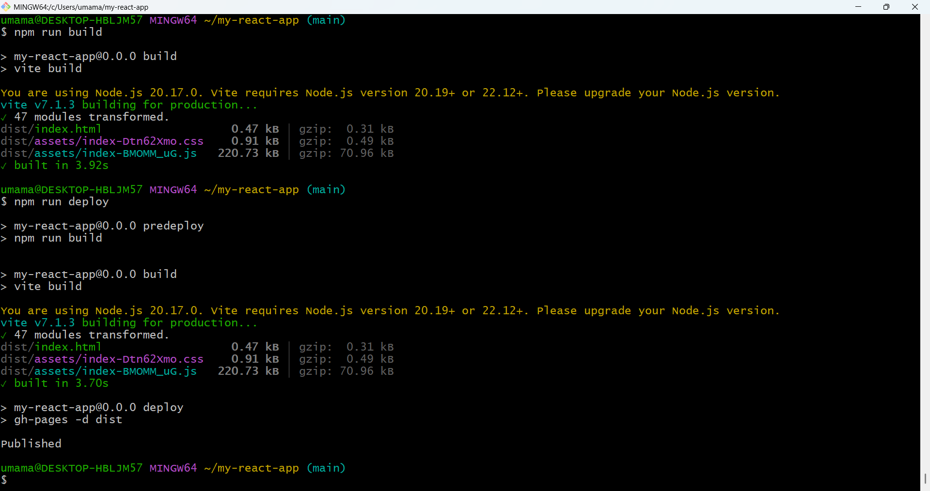

After deployment, go to your repo **Settings → Pages** to confirm the live URL:  
<https://vommidapuchinni.github.io/my-react-app>

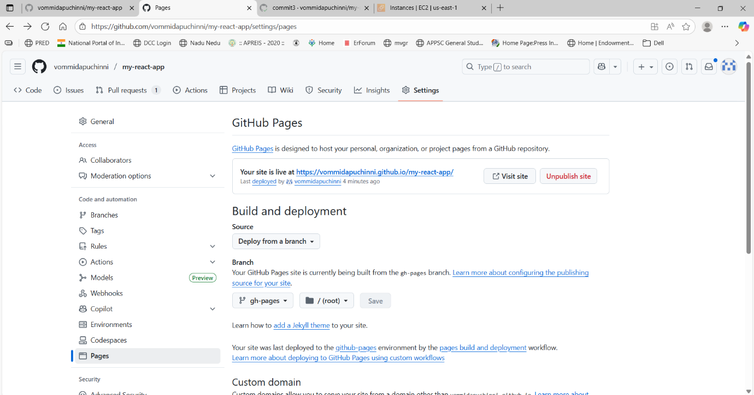

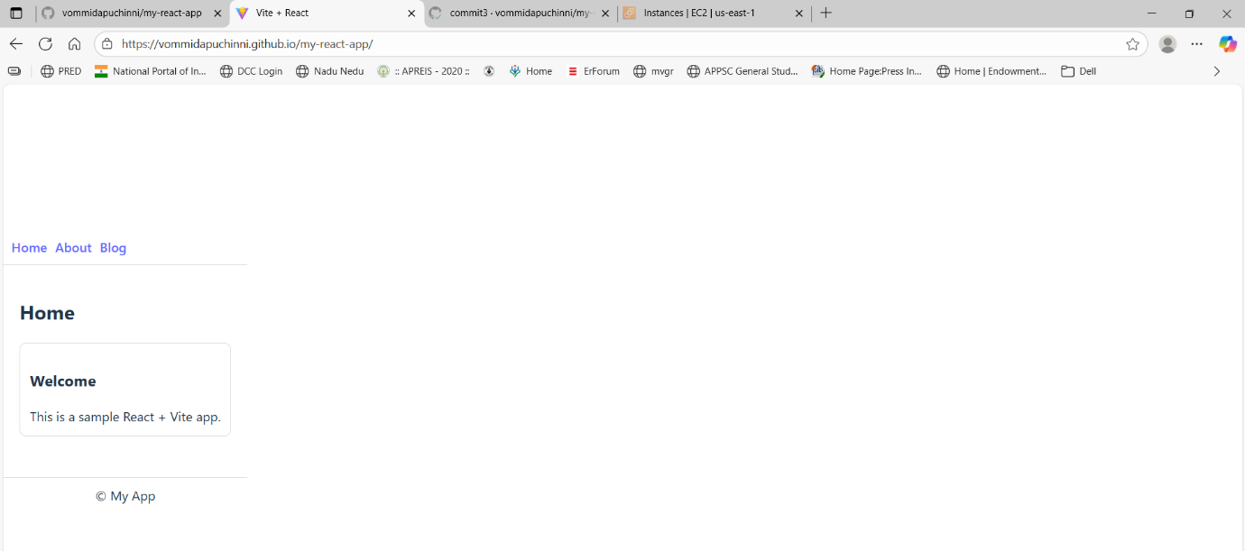

Preview Locally: npm run preview

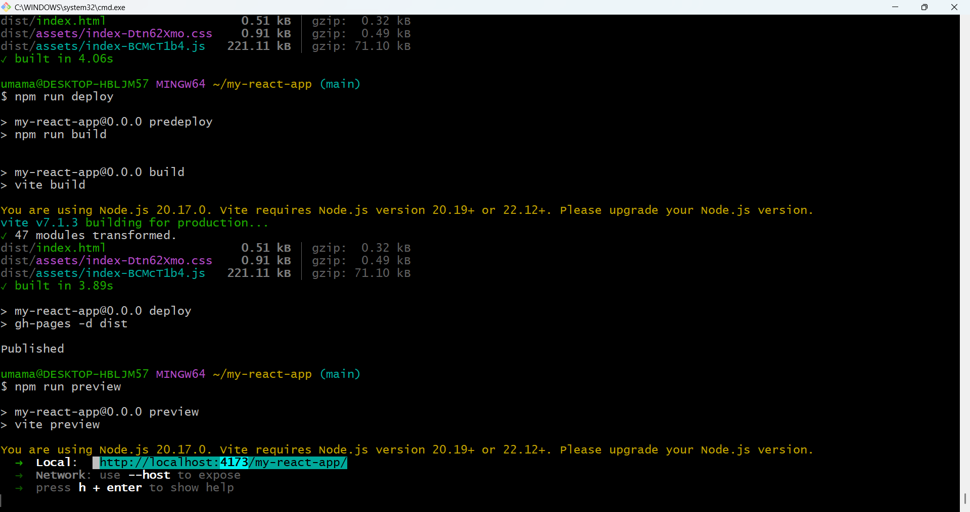

* Opens your production build locally at http://localhost:4173.

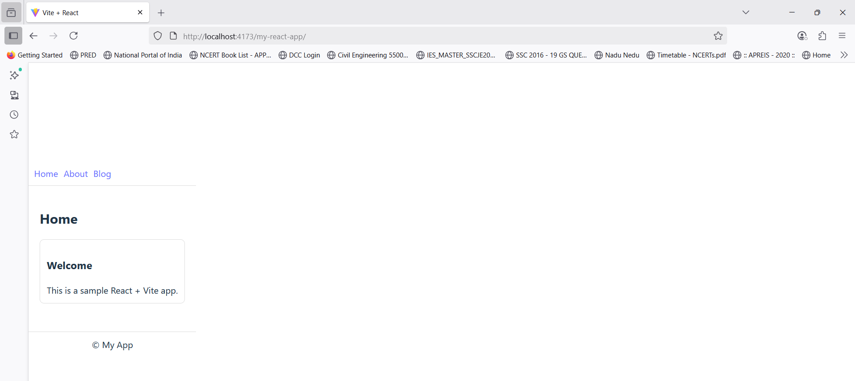

**Troubleshooting**

* **Container restarts** → check Dockerfile build stage.
* **Logs not in CloudWatch** → verify agent config, JSON path, and volume mapping.
* **Workflow fails** → confirm SSH keys and IAM role permissions.
* **App not accessible** → check port mapping and EC2 security group.

**Key Concepts**

* **Docker multi-stage build**: Node.js build → Nginx serve.
* **Docker Compose**: defines service, ports, and log volume.
* **CloudWatch Agent**: collects logs from host directory to log groups.
* **CI/CD with GitHub Actions**: auto-deploys on branch push using SSH.
* **Monitoring**: logs viewable in CloudWatch for staging (/staging/react-app) and production (/production/react-app).

**Conclusion**

Successfully deployed a React app with **staging and production environments** on AWS EC2 using **Docker** and **GitHub Actions CI/CD**. Logs are collected in **CloudWatch** for monitoring.